Alder & Finch - employee handbook
Effective january 1 2027 - version 3

Alder & Finch - employee handbook
effective january 1 2027 - version 3

welcome
welcome to Alder & Finch! we opened the Main Street shop in 2016 with one idea - sell well made things for the home, and know our customers by name. we've grown to two shops, an online store and 24 people, and we still want every customer to feel like a regular.
this handbook explains how we work, what you can expect from us and what we expect from you. it doesn't cover everything, so if something isn't in here, ask your manager or Jordan in the office. we're glad you're here.
Dana Alder and Rob Finch, owners

1. about us
Alder & Finch sells furniture, kitchenware, textiles and gifts from about 60 small makers, most of them within a day's drive of the shops. our values:
- know the product - if a customer asks where it's made, we can tell them
- look after the customer in front of you before the phone or the screen
- leave the shop better than you found it
- be straight with each other

how we're organized
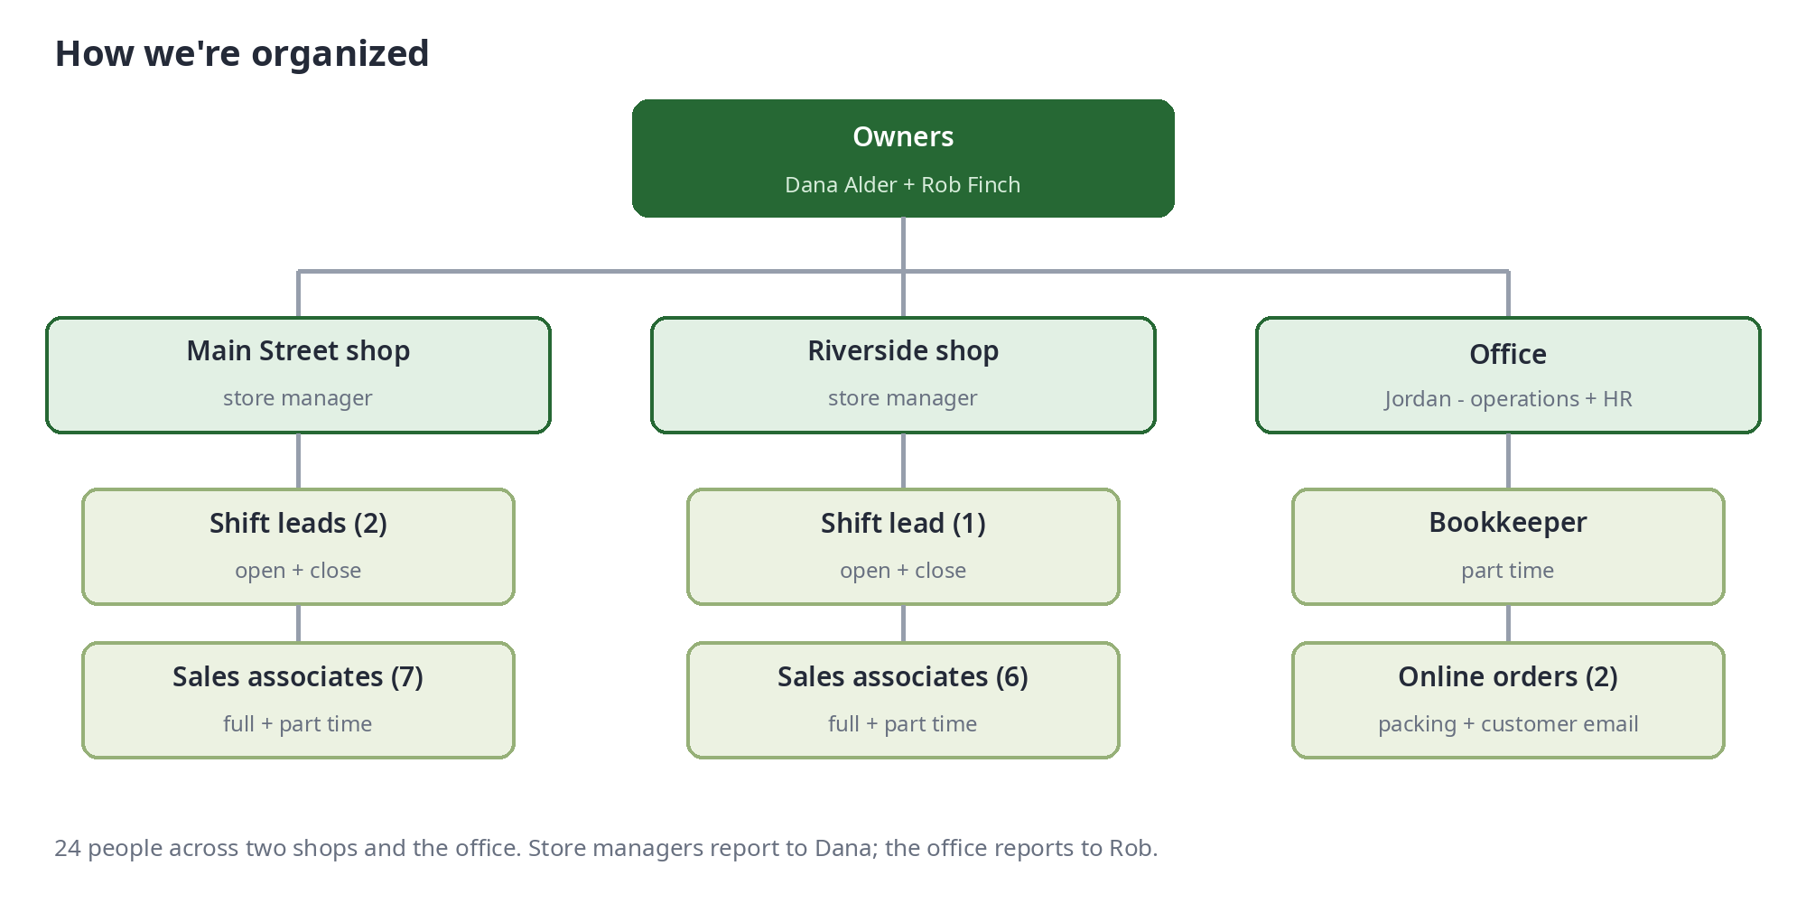

2. employment basics

at-will employment
employment at Alder & Finch is at-will. you or the company can end it at any time, with or without a reason or notice. nothing in this handbook is a contract or a promise of employment for any length of time.

employee types
type | hours | PTO | health insurance
full time | 32+ hours a week | yes | yes, after 60 days
part time | under 32 hours a week | yes (pro rata) | no
seasonal | nov-dec only | no | no

your offer letter says whether you're exempt (salaried, no overtime) or non-exempt (hourly, paid overtime). most shop roles are non-exempt.

equal opportunity
we hire, pay, train and promote people on their skills and their work. we don't discriminate on race, color, religion, sex, sexual orientation, gender identity, national origin, age, disability, genetic information, veteran status or any other status protected by law.

your first 90 days
your first 90 days are an introduction period. you'll have a check-in with your manager at 30 and 90 days. it doesn't change the at-will relationship - it's just a chance for both of us to see how it's going.

3. hours, breaks and pay
shop hours are 10am-6pm monday to saturday and 11am-5pm sunday. shifts start 30 minutes before opening and end 30 minutes after closing. the schedule is posted in the scheduling app two weeks ahead.
- swaps: agree it with the other person, then get your shift lead to approve it in the app
- running late or sick: call the shop (not a text) at least 2 hours before your shift
- breaks: 30 minute unpaid meal break on shifts over 6 hours, plus a paid 10 minute break for every 4 hours worked. where local law gives you more, you get more
- clock in and out on the till for every shift and every meal break. never clock in or out for someone else

overtime
non-exempt employees are paid overtime as the law requires. all overtime has to be approved by your store manager before you work it - but if you work it, you'll be paid for it.

pay schedule
pay period | payday | how
every two weeks, sunday to saturday | the friday after the period ends | direct deposit - pay stubs are in the payroll app
if payday is a holiday | the working day before | same

if you think your pay is wrong, tell Jordan straight away and we'll fix it on the next payday at the latest.

4. time off

paid time off (PTO)
PTO covers vacation, sick days and personal time. it builds up every pay period:
years with us | full time | part time
less than 2 | 4 hours per pay period (13 days a year) | 1 hour per 16 hours worked
2 to 5 | 5 hours per pay period (16 days a year) | 1 hour per 14 hours worked
over 5 | 6 hours per pay period (19.5 days a year) | 1 hour per 12 hours worked

you can carry over up to 40 hours into the next year. if your city or state gives you more sick time than this, the law applies and we'll follow it.

how to book time off
- check the shop calendar in the scheduling app - november and december are blacked out for shop staff except in emergencies
- request it in the app at least 2 weeks ahead (4 weeks for a week or more)
- your store manager approves or declines within 3 working days
- once it's approved, it's yours - we won't cancel it without asking you

company holidays
holiday | shops | office
new year's day | closed | closed
memorial day | open - holiday pay 1.5x | closed
independence day | closed | closed
labor day | open - holiday pay 1.5x | closed
thanksgiving | closed | closed
christmas day | closed | closed

other leave
jury duty, voting time, bereavement leave and military leave are covered by our leave policy and by law - talk to Jordan and we'll work it out with you.

5. benefits
benefit | who | from when
health insurance (we pay 70% of the employee premium) | full time | first of the month after 60 days
staff discount - 25% off everything, 40% off one item a month | everyone | day one
401(k) with 3% match | everyone 21+ | after 6 months
maker visits - paid half day a year to visit one of our makers | everyone | after 1 year

full details are in the benefits guide from Jordan. if this handbook and a plan document ever disagree, the plan document wins.

6. how we treat each other
we expect everyone to:
- be on time and ready to work
- treat customers, makers and each other with respect
- be honest - with money, with stock and with your time
- keep the shop safe and tidy
- follow the till and cash procedures (see the shop SOPs)

no harassment
harassment of any kind - including sexual harassment, and harassment based on any of the things listed under equal opportunity - isn't tolerated from anyone: staff, managers, owners, customers or makers. that includes comments, jokes, messages, images and touching.

raising a concern
- if you can, tell the person their behavior isn't ok
- tell your store manager - or if it's about your manager, go to Jordan or either owner
- you can also email concerns@alderandfinch.example, which goes to Jordan and Dana
- we'll look into it quickly and as privately as we can, and tell you when it's dealt with
nobody will be punished for raising a concern in good faith, or for helping with an investigation.

7. dress code
you're the face of the shop. wear clean, neat clothes you can move in - no logos bigger than your hand, no ripped clothes. closed toe shoes on the shop floor and in the stockroom. we give you two aprons a year. if you need to dress differently for religious or medical reasons, talk to Jordan and we'll make it work.

8. phones, technology and social media
- personal phones stay in the staff room during shifts, except shift leads on call
- the till, laptops and the shop tablet are for work. don't install anything on them
- never share customer details, sales figures or maker prices outside the company
- you're welcome to post about the shop, but don't speak for Alder & Finch, and never post photos of customers
- passwords are personal - don't share them, and tell Jordan if you think one is known

9. health and safety
report every injury, however small, the same day:
- get first aid - the kit is in the staff room at both shops
- tell your shift lead or store manager
- fill in the incident form (shop tablet > forms)
- if you need a doctor, tell Jordan so we can sort out workers' compensation
lift heavy furniture with two people and the cart - always. keep fire exits and the stockroom doorway clear at all times.
if the fire alarm goes, leave by the nearest exit, don't stop for belongings, and go to the assembly point. the shift lead takes the schedule and checks everyone is out.
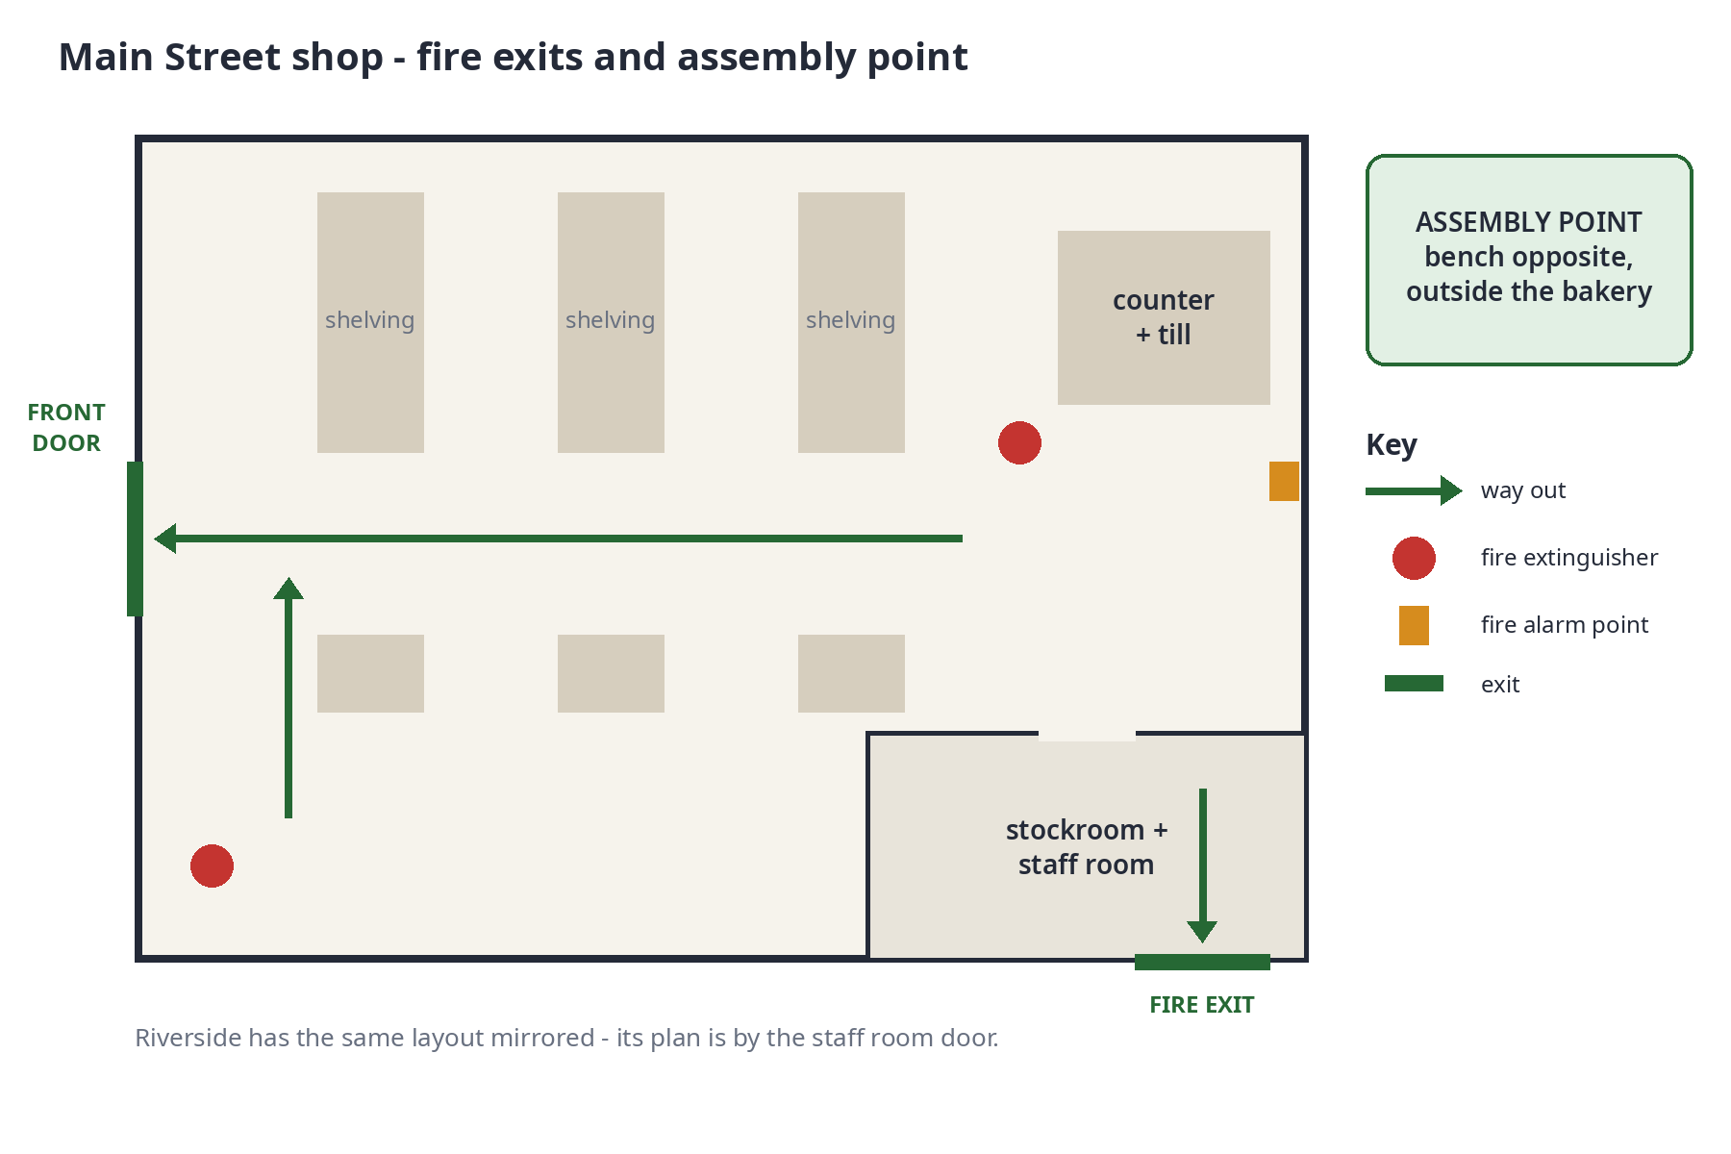

10. leaving Alder & Finch
- please give us 2 weeks notice in writing (email is fine) - 4 weeks for managers
- return your keys, aprons and staff discount card on your last day
- your final pay will be paid as the law requires, including any unused PTO where the law or this policy says so
- we'd like to do a short exit chat - it's optional, but it helps us get better

who to ask
question about | ask | how
your schedule, swaps, time off | your shift lead or store manager | scheduling app or in person
pay, PTO balance, benefits | Jordan (office) | jordan@alderandfinch.example
a concern about someone at work | your store manager, Jordan or an owner | in person or concerns@alderandfinch.example
anything in this handbook | Jordan | any time

changes to this handbook
we review this handbook every year and may change it at any time. we'll tell you about any change in writing before it takes effect.

handbook acknowledgment
I have received the Alder & Finch employee handbook (version 3, effective january 1 2027). I understand it is my responsibility to read it and to ask if anything is unclear. I understand that my employment is at-will and that this handbook is not a contract.
employee name ______________________________
signature ______________________________ date ______________
manager ______________________________ date ______________
please sign and return this page to Jordan. keep the rest of the handbook.

