SOP - invoicing + late payment follow up
Juniper Row Studio - finance/admin

SOP - invoicing + late payment follow up
Juniper Row Studio - finance/admin
sop number | SOP-FIN-003
version | 4
effective date | 09/01/2026
owner | ops manager (Priya Nair)
approved by | founder (Sam Whitlock)
review | every 12 months, or sooner if the process changes

1. purpose
so every client gets invoiced on time and the same way, and late payments get chased politely and consistently without Sam having to do it. we're 8 people - cash flow matters

2. scope
all client invoices - project milestones and monthly retainers. does NOT cover supplier bills (SOP-FIN-004) or refunds / disputed work (talk to Sam)

3. who does what
role | responsibility
ops manager | raises invoices, sends reminders, keeps the invoice tracker up to date
project lead | confirms the milestone is signed off before we invoice, makes the day 14 call
founder | day 30 call, decides on pausing work, approves any write-off

4. terms we use
- net 30 - payment is due 30 days after the invoice date
- overdue - any day after the due date
- statement - a list of all a client's open invoices, from Ledgerly
- pause - we stop work on the project until the account is up to date

5. before you start
you need: Ledgerly login (finance role), edit access to the invoice tracker sheet, and the client's BILLING contact from the client card - not the project contact, they're often different people

the process at a glance
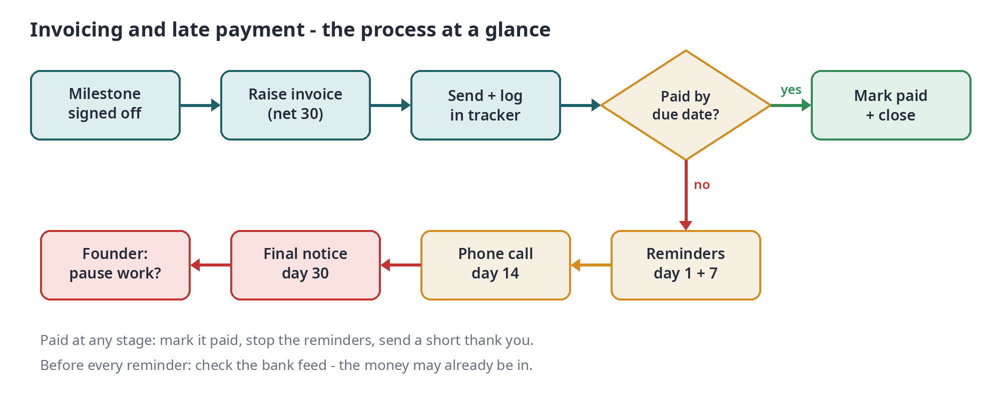

6. raising an invoice
- check the milestone is signed off on the project board (for retainers: invoice on the 1st of the month)
- in Ledgerly go to Sales > New invoice and pick the client
- invoice date = today, terms = net 30 unless the contract says different (check the client card)
- line item = the milestone name from the proposal, e.g. "Phase 2 - website design". add the PO number if the client gave us one - some clients won't pay without it
- check amount, sales tax and billing address against the proposal
- send from Ledgerly to the billing contact, cc the project lead
- log it in the tracker: invoice no, client, amount, date sent, due date
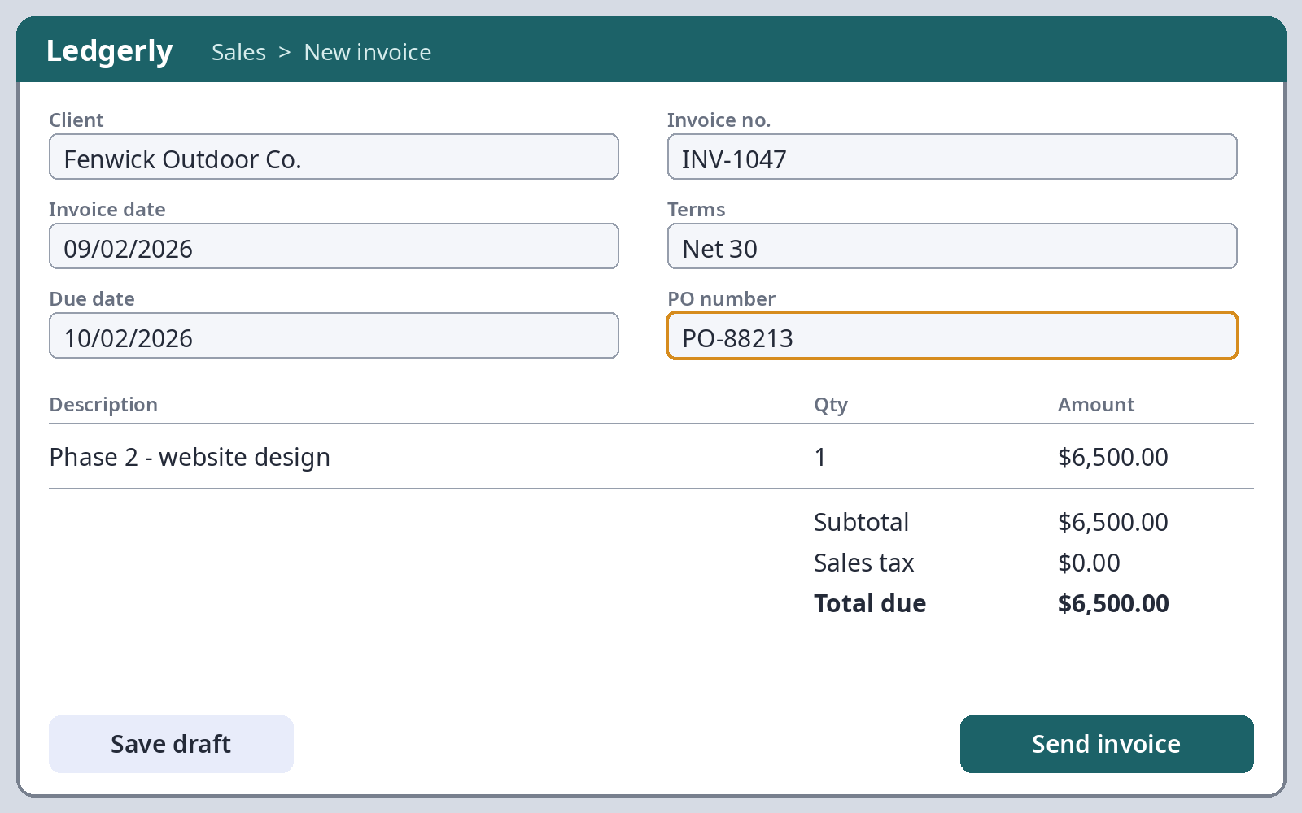

7. Following up late payments

reminder schedule (days are counted from the due date)
when | what | who | how
3 days before due | friendly heads-up | ops manager | email - template A
1 day overdue | reminder 1 | ops manager | email - template B
7 days overdue | reminder 2 + statement | ops manager | email - template C
14 days overdue | phone call | project lead | phone, note it in the tracker
30 days overdue | final notice + founder call | founder | email - template D, then call
45 days overdue | pause work or send to collections | founder | founder decides

rules:
- ALWAYS check the bank feed in Ledgerly before sending anything - the money might already be in
- never threaten. only mention late fees if they're in that client's contract
- log every email and call in the tracker notes column, with the date

email templates (copy, fill in the brackets, send from the accounts inbox)

template A - heads-up
Hi [first name], just a quick heads-up that invoice [number] for [amount] is due on [date]. I've attached it again for easy reference. Thanks! Priya

template B - reminder 1
Hi [first name], invoice [number] for [amount] was due yesterday. Could you let me know when we can expect payment? If it's already on its way, please ignore this. Thanks, Priya

template C - reminder 2
Hi [first name], following up on invoice [number] ([amount]), which is now 7 days overdue. I've attached a statement of your open invoices. If there's a problem with the invoice or you need a PO number from us, just let me know and I'll sort it today. Thanks, Priya

template D - final notice
Hi [first name], invoice [number] for [amount] is now 30 days overdue. Sam will call you this week to talk it through. Under our agreement we may need to pause work on [project] until the account is up to date - we'd much rather not, so please let us know if anything is holding it up. Best, Priya

8. weekly check (every monday)
- run Reports > Aged receivables in Ledgerly
- match it against the tracker - fix anything that's out
- send the reminders that are due this week
- anything over 30 days goes to Sam at the monday ops meeting
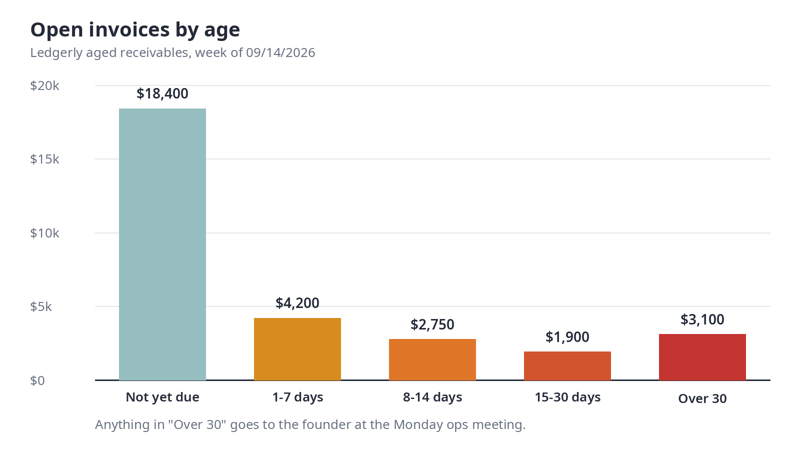

9. when a payment comes in
- match it to the invoice in the Ledgerly bank feed so it's marked paid
- update the tracker (date paid)
- if they paid after a reminder, send a short thank you
- part payment: record it, then email to confirm the balance still owed

10. if something goes wrong
problem | what to do
client says they never got the invoice | check the billing contact, resend. don't change the due date unless Sam agrees
client disputes the amount | stop the reminders, pass it to the project lead + Sam
client asks to pay in instalments | Sam decides. write the agreed plan in the tracker
payment bounces or is reversed | call the client the same day
client needs a W-9 or vendor form first | send ours from Finance/Forms the same day

11. records
invoice tracker: shared drive > Finance > Invoice tracker. keep all invoice emails in the client's folder. keep everything for 7 years (tax)

12. related SOPs
SOP-FIN-001 month-end close, SOP-FIN-004 paying supplier bills, SOP-OPS-002 new client setup

revision history
version | date | what changed | by
1 | 02/2024 | first version | Sam Whitlock
2 | 08/2024 | added the day 14 phone call | Priya Nair
3 | 03/2025 | moved from spreadsheets to Ledgerly | Priya Nair
4 | 09/2026 | added the heads-up before the due date (template A) | Priya Nair

read and understood - new finance/admin staff sign here, copy to Sam
name ____________________ signature ____________________ date __________
approved by ____________________ signature ____________________ date __________

