New Hire Training - Sales Floor + Till
Harbor & Pine Outfitters - Store Team Onboarding, Week 1

New Hire Training - Sales Floor + Till
Harbor & Pine Outfitters - Store Team Onboarding, Week 1
Who this is for: New sales associates, first week. Trainer runs it over 3 x 2hr sessions, trainee keeps the manual after.
By the end they should be able to:
- Greet + help customers using the HELLO approach
- Ring up a sale on the till
- Do a return/exchange
- Open + close a till drawer
- Know who to call when stuff goes wrong

SESSION 1 - Welcome + the Sales Floor
- Quick welcome, store tour (stockroom, fitting rooms, fire exits, first aid kit is behind the till)
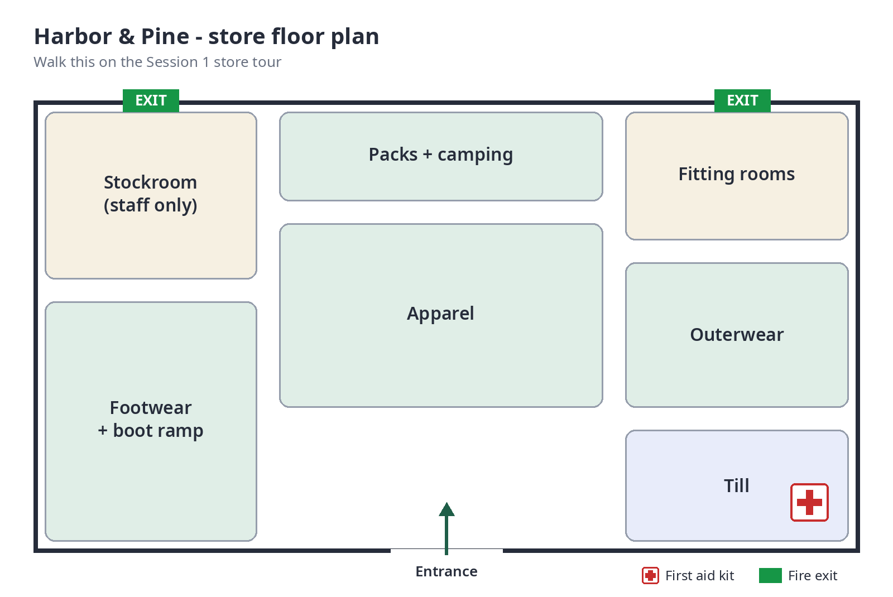
- Our promise: "gear you trust, help that's honest" - we don't push upsells people don't need

HELLO approach (this is the main thing for session 1)
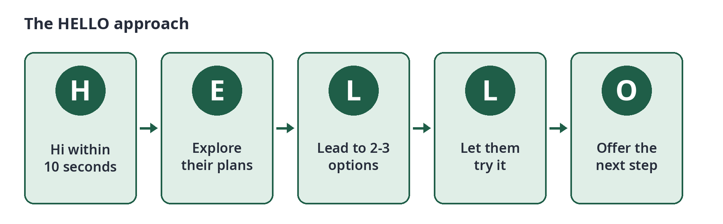
- H - hi within 10 seconds, eye contact, no "can I help you"
- E - explore what they're doing (trip? weather? how long?)
- L - lead them to 2 or 3 options max not the whole wall
- L - let them try it - fitting room / pack weights / boot ramp
- O - offer the next step: till, hold it for them, or order online if no size
Role play: Trainee does HELLO 3 times w trainer as customer. Trainer uses the observation checklist (see end).

Session 2 - The Till

Ringing up a sale
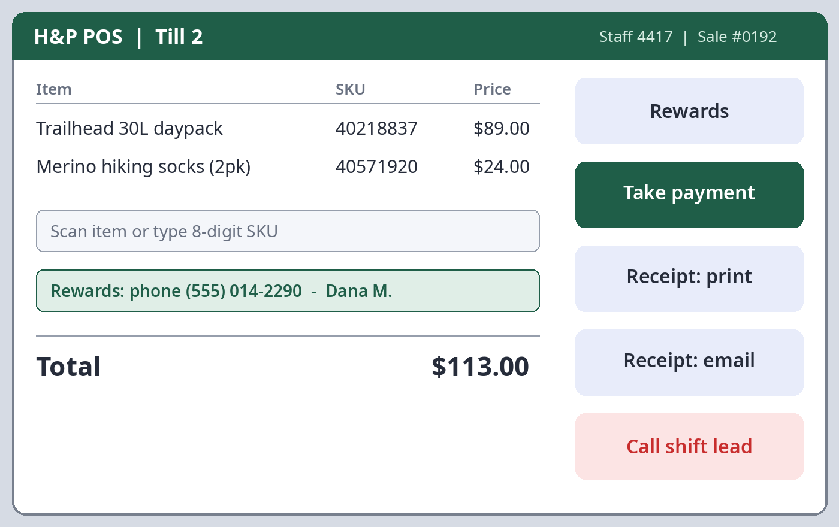
- Log in with your staff number
- Scan items (if barcode won't scan type the 8 digit SKU from the swing tag)
- Ask for rewards number - phone number works
- Take payment - card, contactless, cash, gift card
- Offer receipt printed or emailed
- Bag it, thank them by name if you have it from rewards

Returns + exchanges - rules (from the policy sheet)
Situation | What happens
within 60 days, with receipt | full refund to original payment
within 60 days, no receipt | store credit at lowest price in last 30 days
over 60 days | manager decision, don't promise anything
used gear | only if faulty, manager checks it

Opening + closing the drawer
Open: Count float ($200: 10x$10, 10x$5, 40x$1, rest in coin), sign the float sheet.
Close: Count drawer, take out everything over float, put in safe bag, both people sign, bag goes in drop safe NOT the office.

SESSION 3 - WHEN THINGS GO WRONG + WRAP UP
- Till freezes: dont restart it, call shift lead
- Card declined: ask for another payment, never say "declined" loudly, say "didn't go through"
- Customer upset: listen, dont argue, get shift lead
- Anything with money that doesn't add up: stop, get shift lead, don't try to fix it
Who to call: Shift lead first (radio ch 2), store manager second, IT helpdesk ext 400 for till problems only.

Knowledge check (trainee does on their own, trainer marks)
- What are the 5 steps of HELLO? ______________________________
- Customer has receipt, bought 45 days ago, what happens? ______________________________
- What's the float amount? ______________________________
- Till freezes mid sale, what do you do? ______________________________
- Where does the closing safe bag go? ______________________________

Trainer observation checklist - HELLO role play
Behaviour | Yes | Not yet
greeted within 10 sec
asked about their plans
showed 3 options max
offered to try
offered next step

Sign off - copy goes to store manager
Trainee name ____________________ signature ____________________ date __________
Trainer name ____________________ signature ____________________ date __________

